CLOUD COMPUTING LAB

Name: Maria Abdul Malik
Reg No: 2023-BSE-076
Submitted to: Sir Muhammad Shoaib
Class: 5B

LAB #08

Task 1 — Create an AWS account and enable UAE (me-central-1)
task1_open_signup_page.png
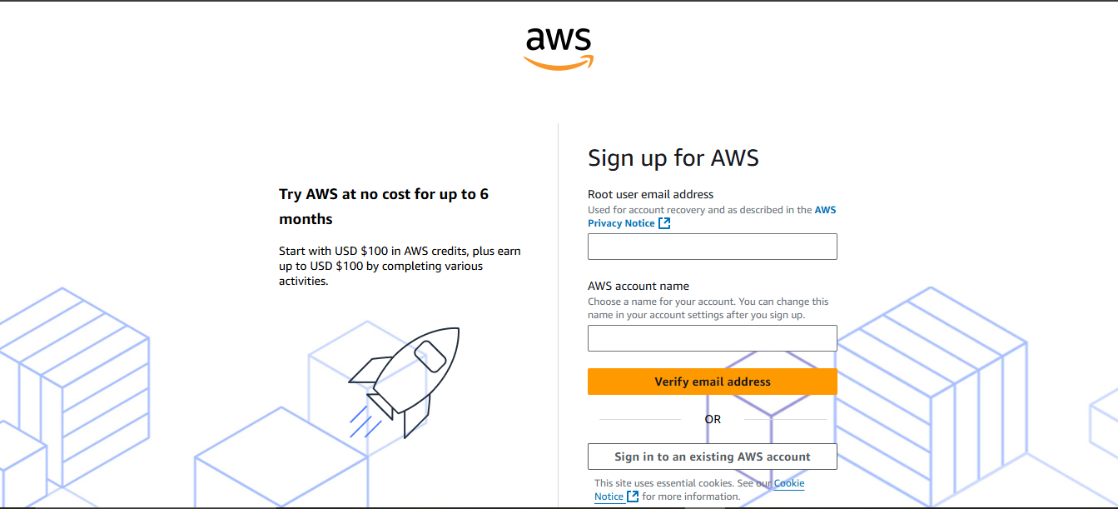

task1_root_signed_in.png
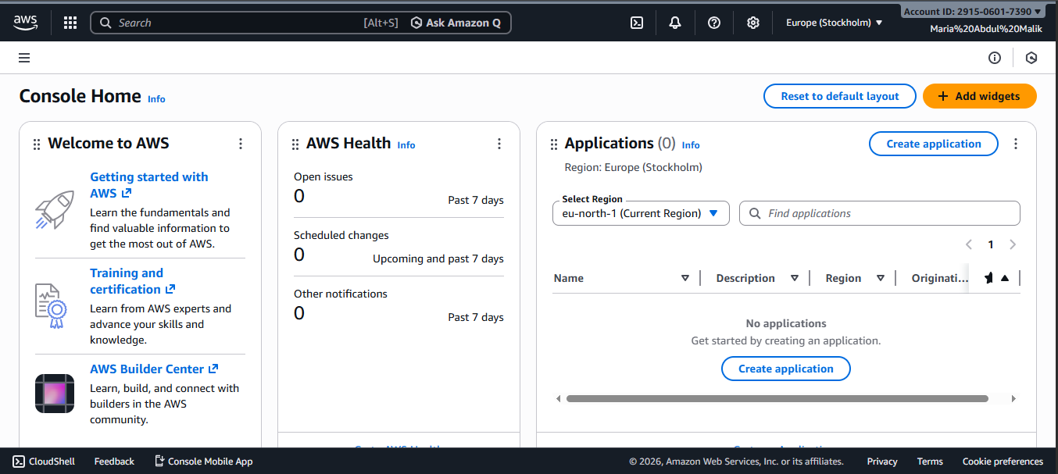
task1_enable_region_me-central-1.png
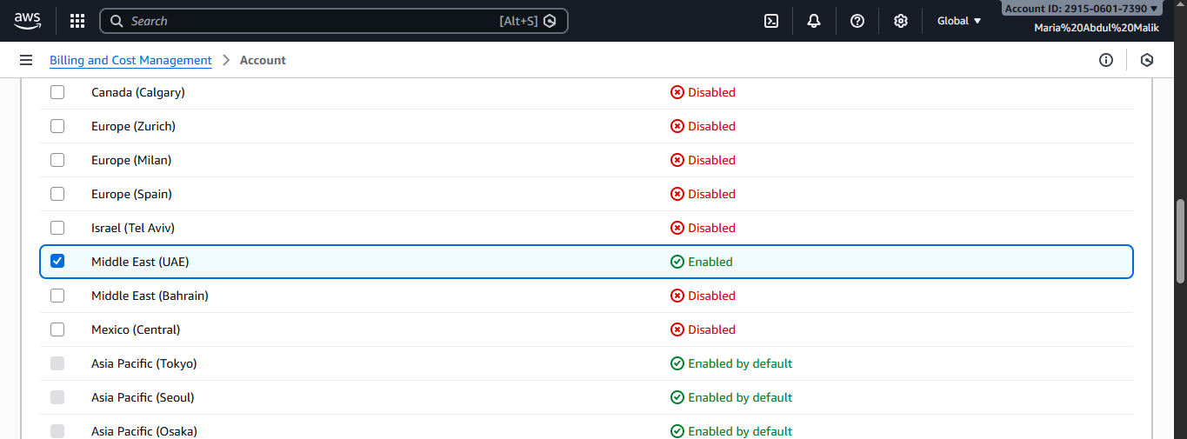
task1_summary.png

Task 2 — Create IAM Admin and Lab8User with console access

task2_open_iam_console.png
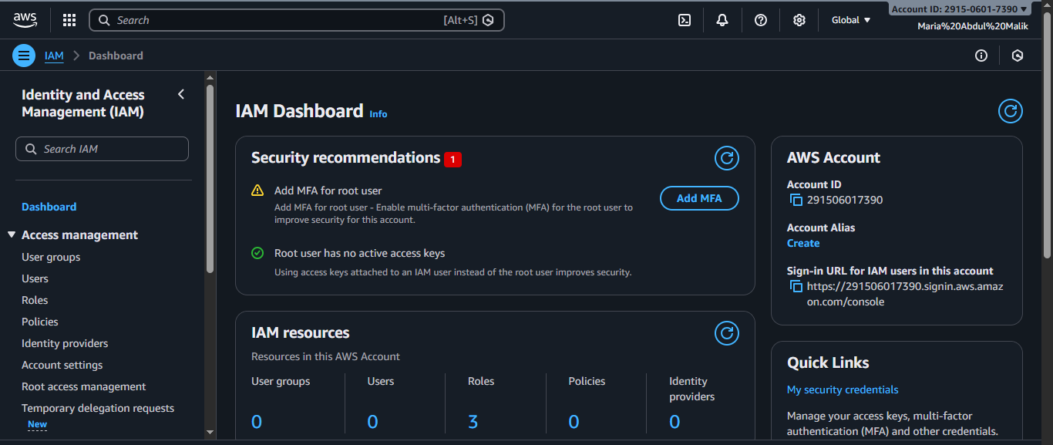
task2_admin_create_confirmation.png
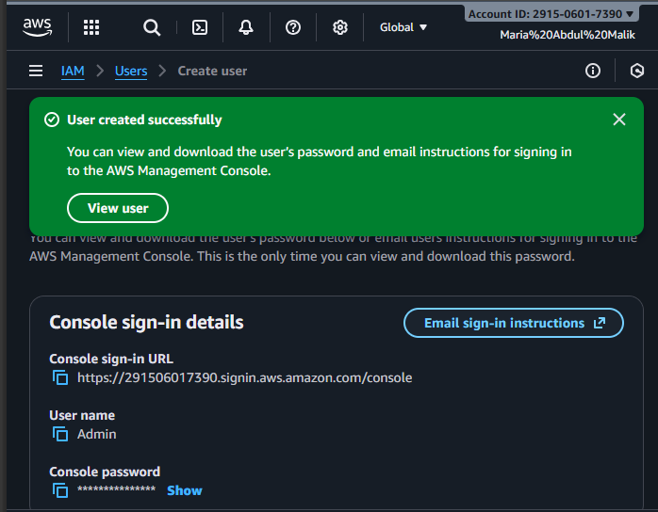
task2_admin_csv_and_signin_url.png
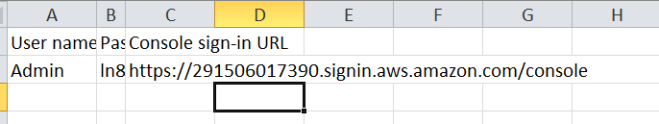
task2_admin_console_after_login.png
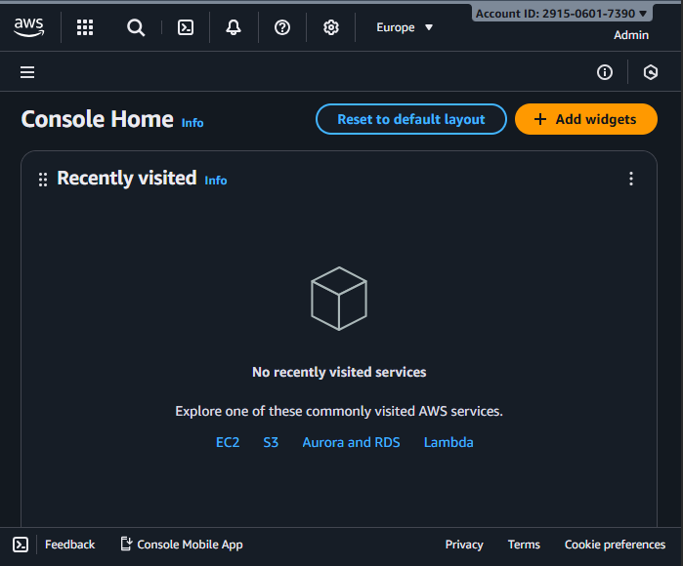
task2_create_lab8user_and_csv.png
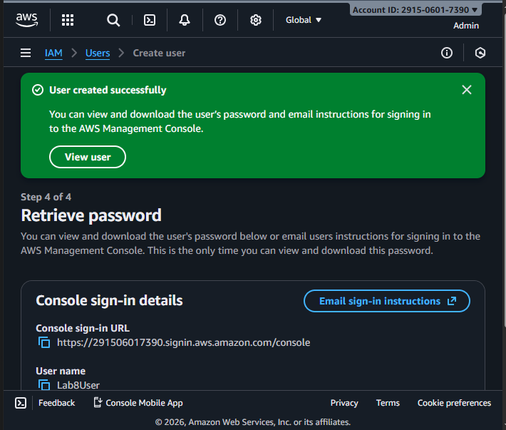
task2_lab8user_csv_saved.png
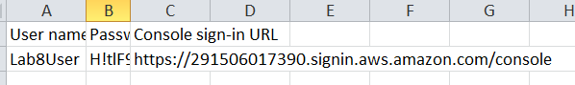
task2_lab8user_logged_in.png
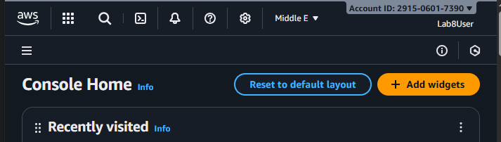
task2_summary.png

Task 3 — Inspect VPC resources (in UAE me-central-1)
task3_open_vpc_console.png
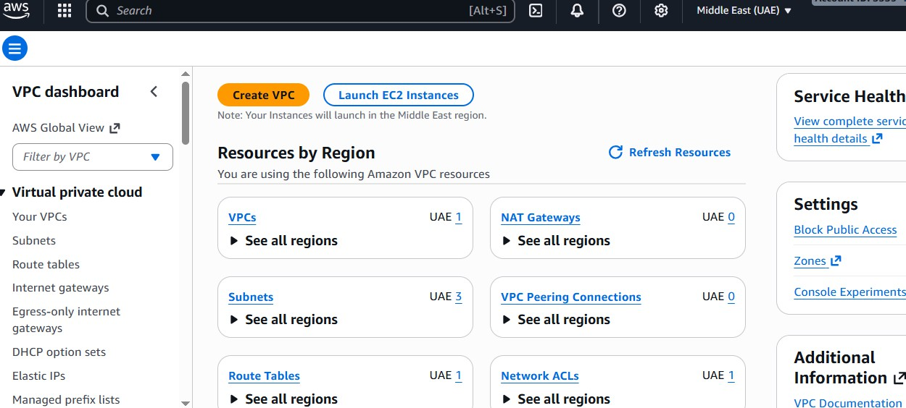
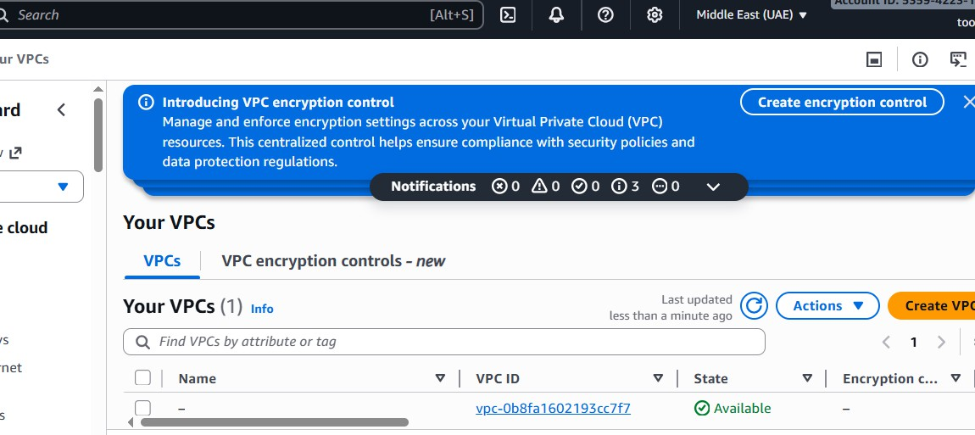
task3_vpcs_list.png
task3_subnets_list.png
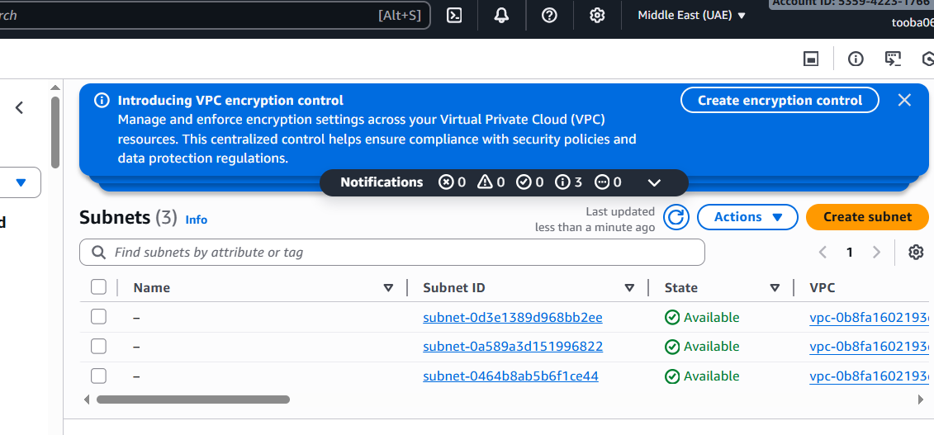
task3_route_tables_list.png
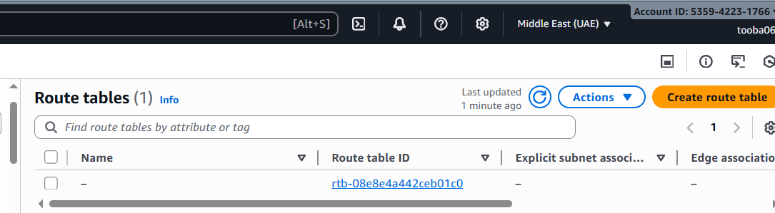

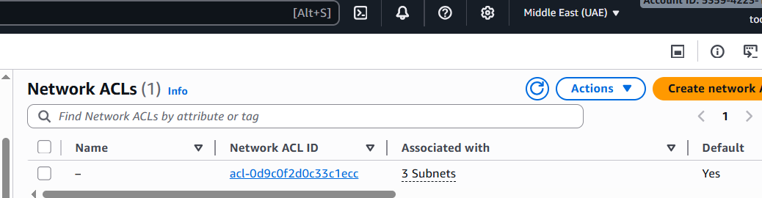
task3_network_acls_list.png
task3_summary.png
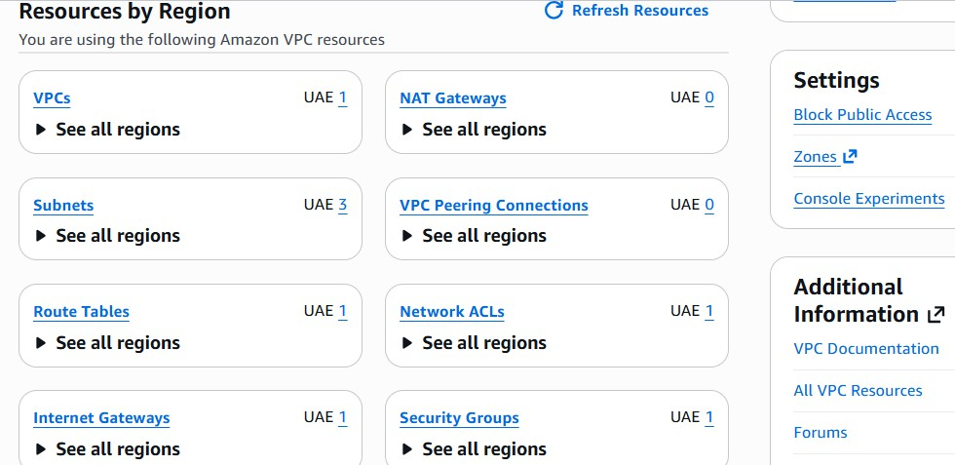

Task 4 — Launch EC2, SSH, install Docker & Docker Compose, deploy Gitea
task4_open_ec2_console.png
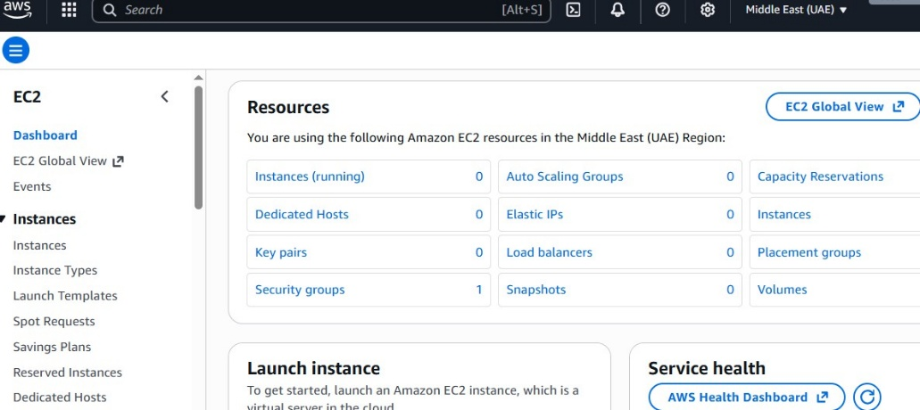
- task4_launch_instance_config.png
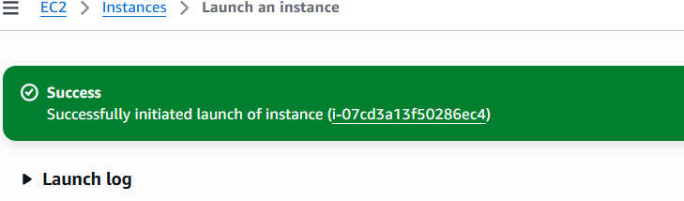
- task4_keypair_download.png
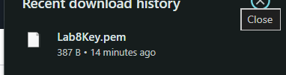
task4_instance_running_console.png
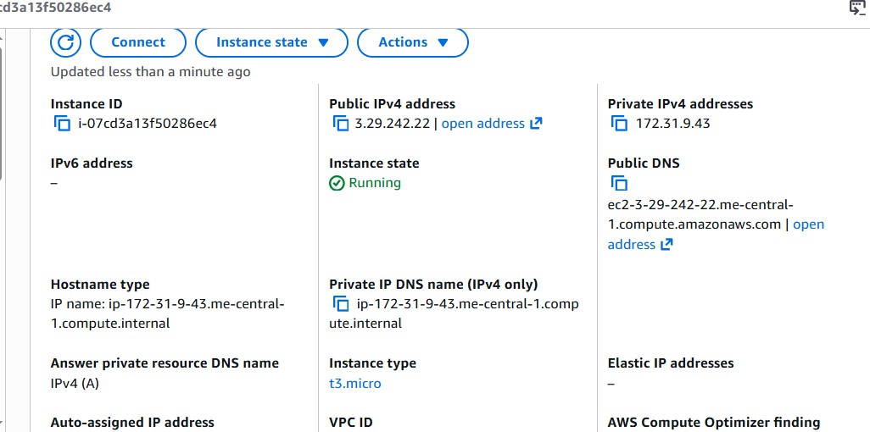
- task4_ssh_from_windows_to_ec2.png
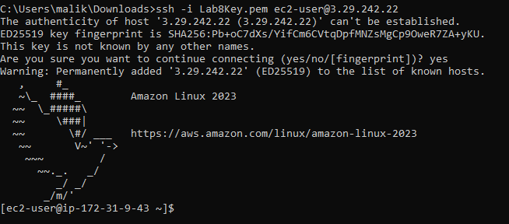
- task4_ec2_install_docker_compose_started.png
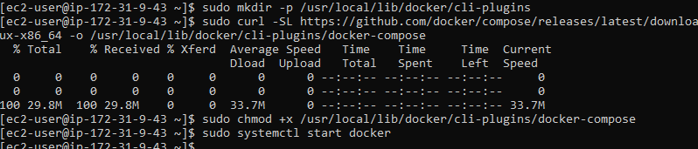
- task4_vim_compose_yaml_paste.png
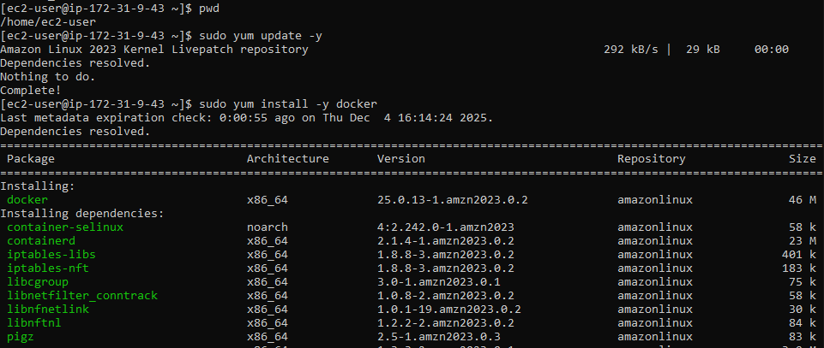
- task4_compose_yaml_saved_ls.png
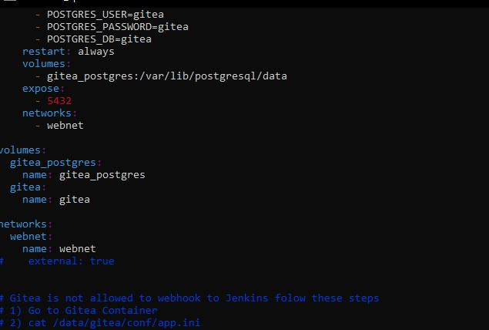
- task4_compose_yaml_saved_ls.png
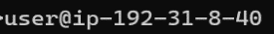
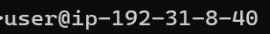
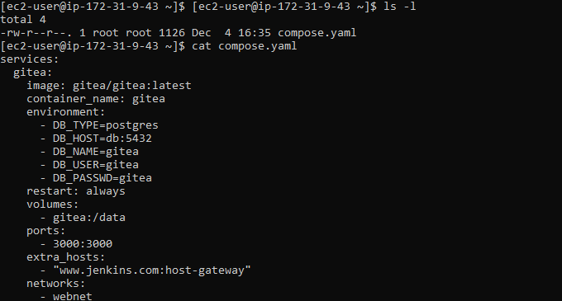
- task4_usermod_and_groups_before_after.png
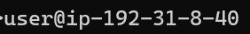
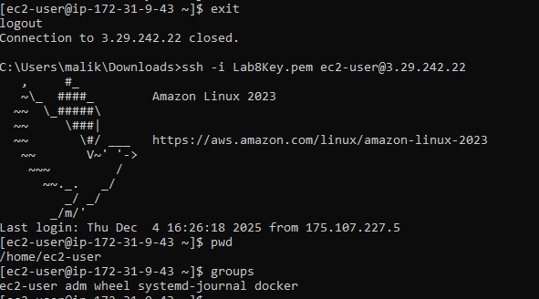
- task4_docker_compose_up.png
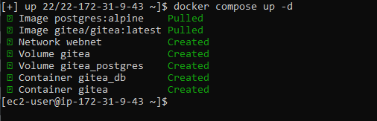
- task4_security_group_allow_3000.png
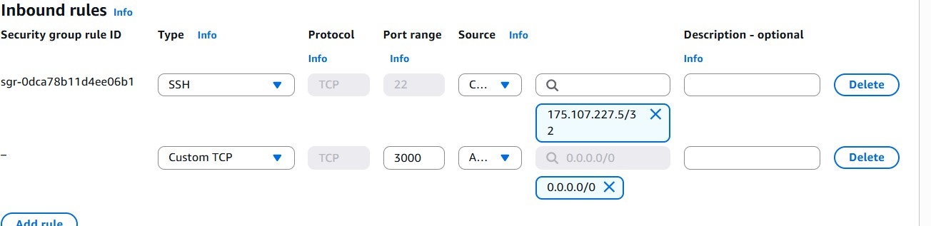
- task4_gitea_install_page.png
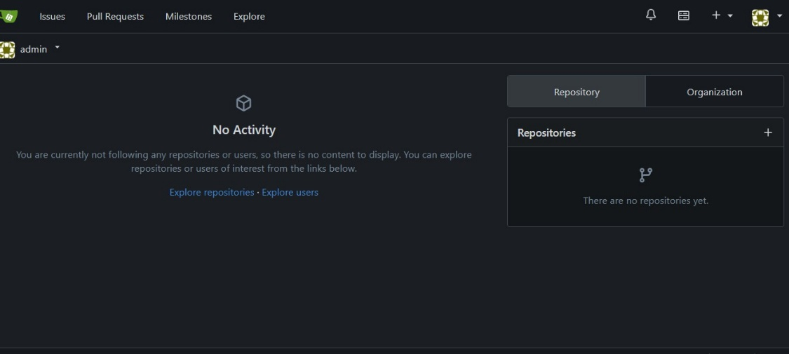
task4_gitea_create_repo.png
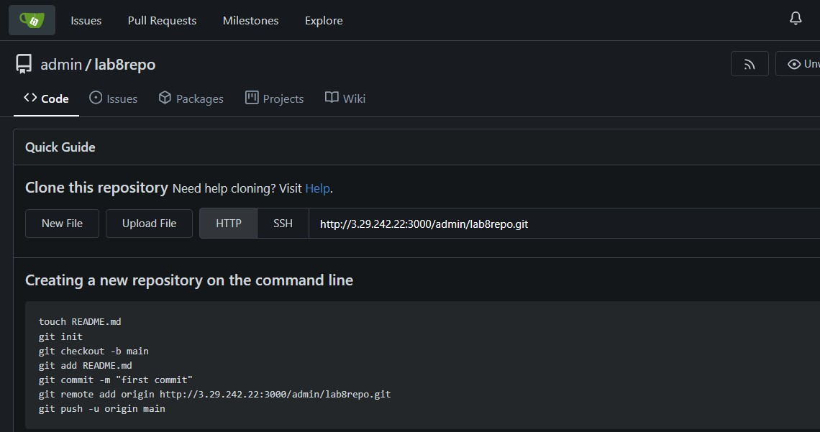
- task4_summary.png
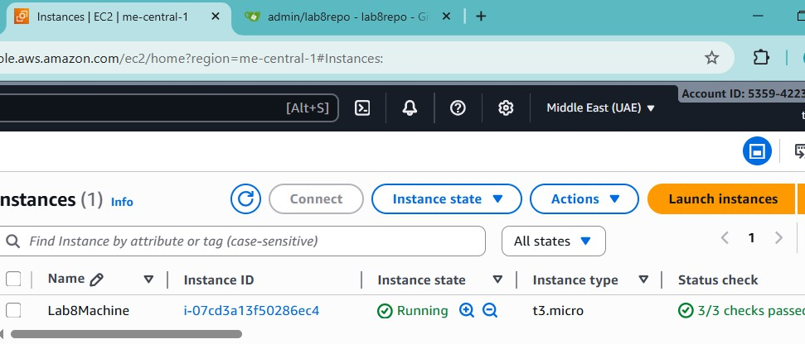

Cleanup — Remove resources to avoid charges
cleanup_terminate_instance.png
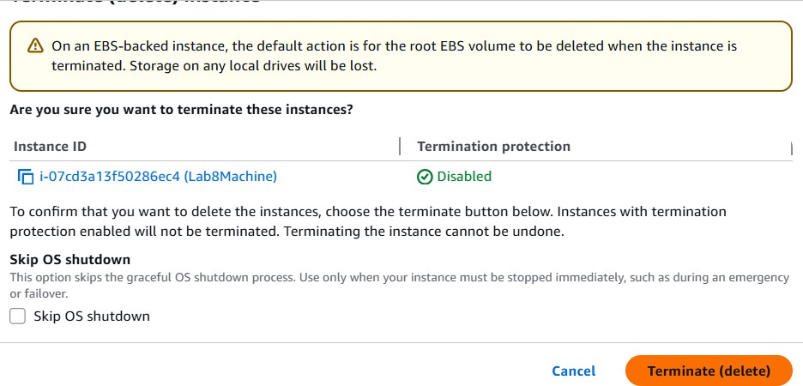
- cleanup_delete_volumes_snapshots.png
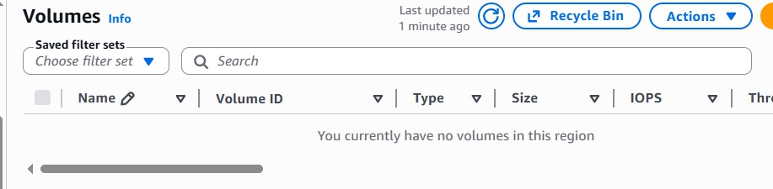
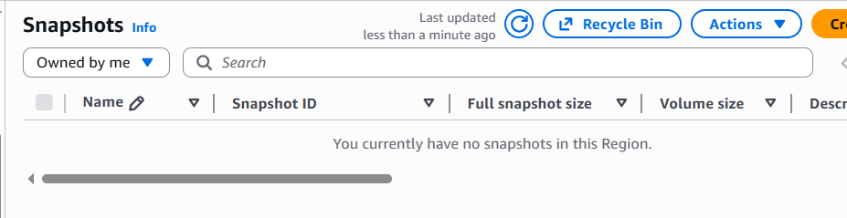
- cleanup_delete_security_group_and_keypair.png
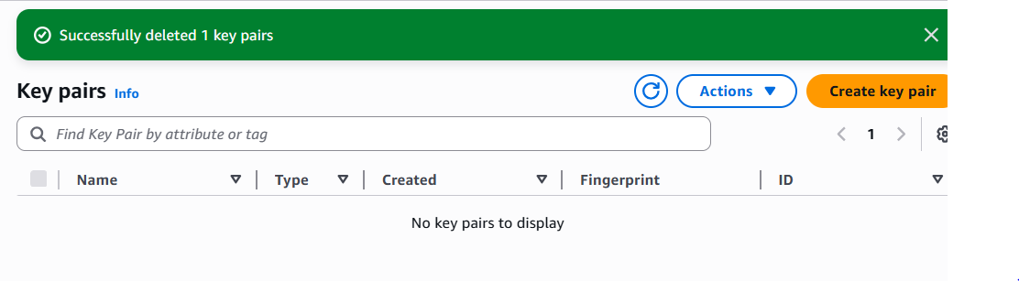
- cleanup_iam_users_deleted.png
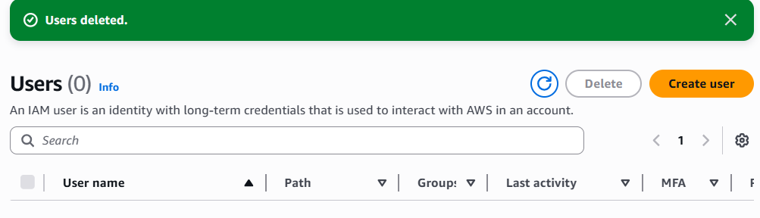
- cleanup_summary.png
